**Q1. Max Consecutive Ones**

Link: <https://leetcode.com/problems/max-consecutive-ones-iii/>

Given an array A of 0s and 1s, we may change up to K values from 0 to 1. Return the length of the longest (contiguous) subarray that contains only 1s.

Example 1: Example 2:

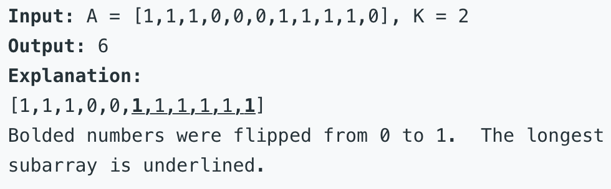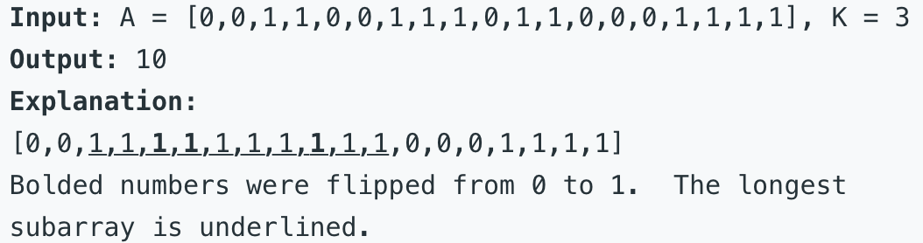

Note:

i) 1 <= A.length <= 20000 ii) 0 <= K <= A.length

**Q2. Longest Substring with At Most Two Distinct Characters**

Link:https://leetcode.com/problems/longest-substring-with-at-most-two-distinct-characters/

Given a string **s**, find the length of the longest substring **t** that contains **at most** 2 distinct characters.

Below are a couple of examples:

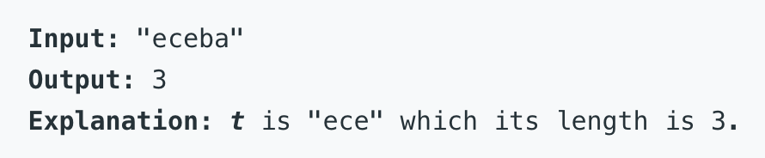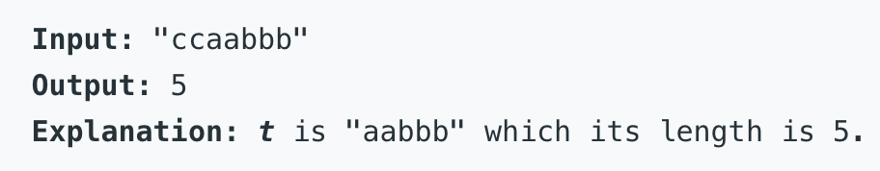

**Q3. Trapping Rain Water**

Link: https://leetcode.com/problems/trapping-rain-water/

Given n non-negative integers representing an elevation map where the width of each bar is 1, compute how much water it is able to trap after raining.

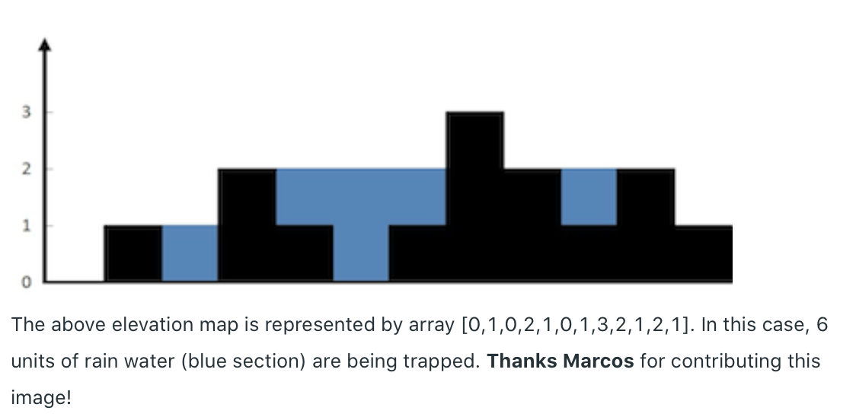

Example:

Input: [0,1,0,2,1,0,1,3,2,1,2,1]

Output: 6

**Q4. Permutation in String**

Link: https://leetcode.com/problems/permutation-in-string/

Given two strings s1 and s2, write a function to return true if s2 contains the permutation of s1. In other words, one of the first string's permutations is the substring of the second string.

Example 1

Input: s1 = "ab" s2 = "eidbaooo"

Output: True

Explanation: s2 contains one permutation of s1 ("ba").

Example 2

Input:s1= "ab" s2 = "eidboaoo"

Output: False

